Mobile Supply Chain Applications
For Intermec Terminal Emulator (ITE)

Merial

How to Perform Account Alias Receipt Transaction (Adjustment In) through the Scanner

Author: Letitia Sims
Creation Date: May 10, 2011
Last Updated: May 10, 2011
Version: 1.0
Devices Used: Intermec CK3, VT/ANSI Application
Purpose: User Training

Approvals:

Roy Stephens

Kathy Jones

- Click Enter or “1” for Default
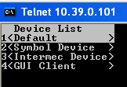

- Enter your Oracle user name and click Enter
- Enter your Oracle password and click Enter

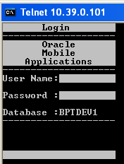

- The following Main Menu screen returns
- Choose “3” for “Inventory Receipts”

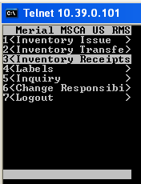

- Click Enter OR “1” to choose “Alias Receipt”

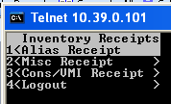

- Enter ATM in all caps (if not already chosen from using the scanner previously)
- To turn on all caps, press the following buttons:
- Press orange button
- Press “B”
- Press orange button
- Enter ATM

NOTE: If you make a mistake, hit the Enter button and start over

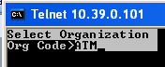

- Click Enter
- The “Alias Rcpt Txn” Screen returns

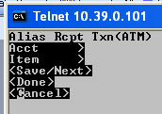

- Choose “Acct” to be used for your transaction (i.e. DESTRUCTION.INDUSTRIAL.ATM, SUPPLY.ISSUE.LAB.SUPPLIES.ATM, etc.) from a list of values by using the scanner keypad:
- Press green button
- Press “I”
- Press green button
- Press “L”

- The list of values will return:

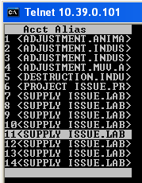

NOTE: To see the full Account Alias, you will need to scroll to the right of the scanner screen. To do this:

- Press orange button
- Press “6”
- Continue to press “6” to scroll to the right
- With orange button still active, Press “4” to scroll back to the left
- With orange button still active, Press “2” to scroll up
- With orange button still active, Press “8” to scroll down

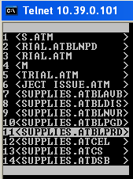

- Click the orange button to deactivate (the orange indicator light goes out at the bottom of the scanner)
- Click the number the corresponds to the account alias you choose
- Enter the item number using the scanner keypad or scanning an item number barcode

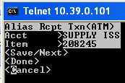

- The item description from Oracle is automatically populated
- With the scanner cursor on “Sub” for sub-inventory, scan the location label

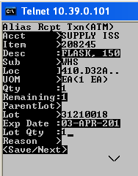

- The sub-inventory and locator will populate on the screen
- The UOM is automatically populated
- With the scanner cursor next to “Qty”, enter the quantity for your transaction
- The quantity next to “Remaining” will automatically populate the same quantity as entered above.
- Click Enter to by pass “Parent Lot”
- With scanner cursor next to “Lot”, enter the lot number using the scanner keypad or scanning a lot number barcode
- Click Enter

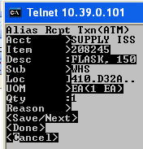

- The scanner cursor will stop next to “Reason”. This is an unused field; click Enter
- Click Enter to complete the transaction

NOTE: Alternatively, if the chosen Account Alias has a mandatory reason code associated with it, there will be a place holder called “Reason Code” that will be present and must have a value entered

- With the scanner cursor next to “Reason Code”, either key in the value using the scanner key pad or pull up the list of values for this field:

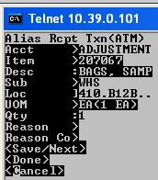

- Press green button
- Press “I”
- Press green button
- Press “L”

- The list of values will return:

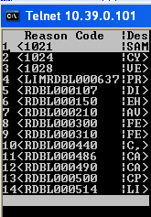

- Click the number next to the Reason Code desired
- The Reason Code is populated on the screen

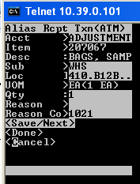

- Click Enter to complete the transaction

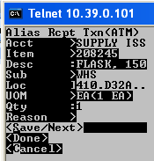

- The message “Txn Success” will return to let the user know the transaction was completed.

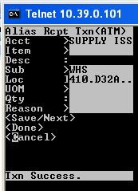

NOTE: The transaction is not complete unless the user clicks Enter where <Save/Next> is the choice.

- To exit this screen, click F2
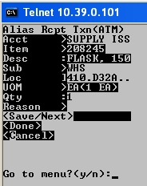

- The question “Go to menu? (y/n)” will return
- Click “Y” button
- The sub-menu returns

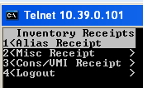

- click F2 again
- The main menu returns

